



FICHA DE SEGUIMIENTO DIARIO
“My school/Time machine”

Date: _________________________________

Name _____________________________________ Group: ___________

- How many activities did you do today?
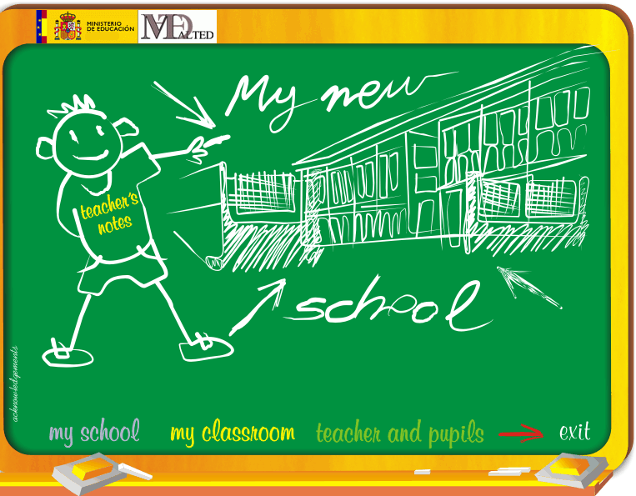
____________________________________________________________________________________________________________

- What was your favourite activity? ☺

________________________________________________________________________

- Which activity didn’t you like? ☹

______________________________
- Did you enjoy the lesson? ________________________________
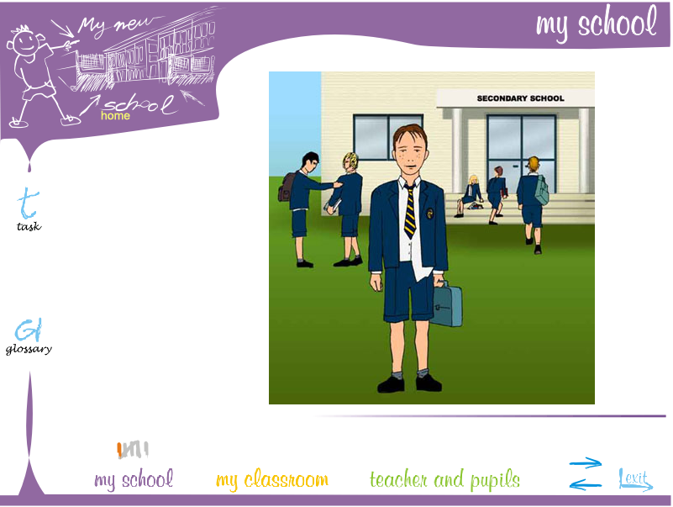
____________________________
- What have you learnt today)

________________________________________________________________________

- Did you have any problems during the lessons? (i.e. internet connection, computer didn’t work…)

________________________________________________________________________________________________________________________________________________

- Is this unit easy or difficult for you to understand it? ______________________

