

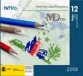

FICHA DE EVALUACIÓN INICIAL/FINAL DEL TEMA
“Time Machine”

Date: ____________________________

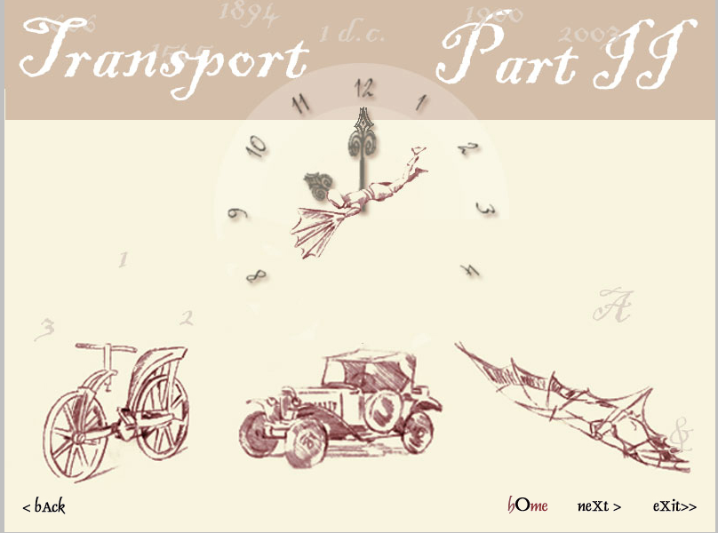
Name: ______________________________________ Group 6º A

- Answer these questions about you?

- Where were you born?

- Did you live in Aguadulce in 2007?

- Was English your favourite subject last year?

- Were your best friends in this classroom last year?

- Did your friend get up at six o’clock am today?

- Complete with the corrrect form of the verb:

- I __________________ football yesterday x He _______________ spaghetti

? She/jump very high yesterday in the P.E. lesson

_________________________________________________________________
- Our best mark in English last year ______________ 10
X They _______________ in the cinema yesterday.
? _________________ they at the park last week?

- Order these sentences:
- Were where yesterday you ______________________________________
- Studying was I English __________________________________________
- Cooked salad mum my yesterday _________________________________
- Pass the we didn’t exam ____________________________________________
- Where you did hide? ______________________________________________

- Listen and write the dates:
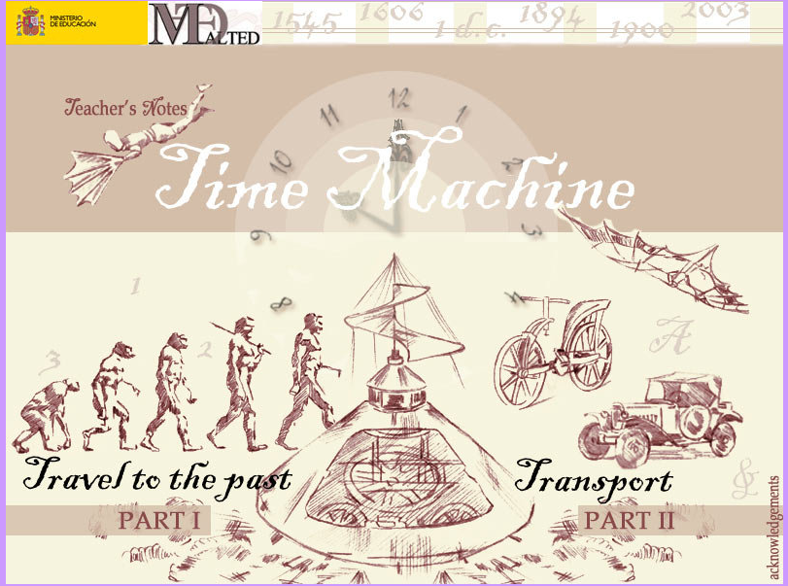

- ______________________

- ______________________

- ______________________

- ______________________

- Listen and write the name of the means of transport that you hear:
- ______________________
- ______________________
- _________________ d) ________________ e) ______________________

- Fill in the sentences:

- I go to school ______ foot
- My father goes to work ______ car
- My mother goes shopping ________ bus

- What time is it?

4:25 ___________________________________________________

6:00 ___________________________________________________

7:15 ___________________________________________________

8: 30 __________________________________________________

4:40 ___________________________________________________

3:45 ___________________________________________________

- Write your daily routine. These expressions can help you:
get up, have breakfast, go to school, have lunch, do my homework, watch TV, have dinner, go to bed

_______________________________________________________________________
_______________________________________________________________________
___________________________________________________________________

- What did you do yesterday? Write at least three sentences.

________________________________________________________________________________________________________________________________________________________________________________________________________________________

