PREVIOUS VOCABULARY TEST for GWINETH AND THE WIZARD & BERTIE (TWENTY QUESTIONS)
Nota: Esta es una versión fotocopiable del cuestionario original elaborado en Proprofs (un “quiz”), que permite a los alumnos responder a las preguntas on line . Si superan un determinado número de aciertos obtienen un “Diploma”. Se puede acceder a él en: http://www.proprofs.com/quiz-school/story.php?title=gwineth--wizard

This is a test to be done before working on the units.

1. What do you call this in English?
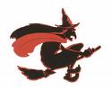

⃞ a bruch
⃞ a wizard
⃞ a witch
⃞ a broom
⃞ an elf

2.
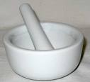 this is a....

⃞ mixer
⃞ crusher
⃞ mortar
⃞ round plate
⃞ soup maker

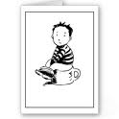
3. The boy is sitting on _________
⃞ a pisser
⃞ a toillet cup
⃞ a defecation cup
⃞ a chamber pot
⃞ a portable toillet

4. A person who predicts the future by the position of the planets, stars, sun and moon is called...
⃞ an astrologer
⃞ a star-researcher
⃞ a fortune teller
⃞ an astrophisics
⃞ a star-teller

5. What does " tweet" mean?
⃞ A popular form of North America dance music.
⃞ Consisting of two identical part.
⃞ Very high and difficult to climb.
⃞ A sharp sound made by a small bird.
⃞ More than once.
6.

This is an__________
( 1 word )

7.
This is a ______________
( 1 word )

8.
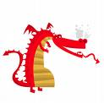This is a ____________

9.
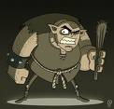This is an_______

10. The opposite of "tiny" is ________
( 1 word )

11.
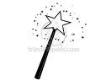This is a magic ________

13. This is ___________

Principio del formulario
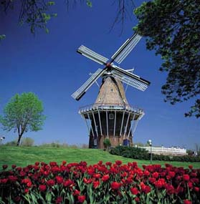
⃞ A windtower
⃞ A windcastle
⃞ A windmill
⃞ A molliner
⃞ A windmixer

13.
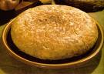
This is a typical Spanish.....

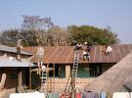
14. They are repairing the....
⃞ roof
⃞ ceiling
⃞ walls
⃞ basement
⃞ ladders

15. Town Hall means.... in Spanish.
⃞ Salón de festejos
⃞ Entrada de la ciudad
⃞ Plaza del pueblo
⃞ Aparcamiento
⃞ Ayuntamiento
16. What is this?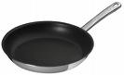
⃞ A saucepan
⃞ A frying pan
⃞ A sarten pan
⃞A frying pot
⃞ A deep fryer
17.
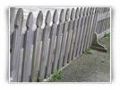
This is a wooden....
( 1 word )
18.
"Mayor" means... in Spanish
⃞ más grande
⃞ más importante
⃞ alcalde
⃞ sendero
⃞ marea baja
19.
You can install 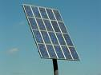to heat the water in your house.
⃞ panel solars
⃞ solar boards
⃞ sun mirrows
⃞ solar panels
⃞ sun bars
20. They've built a small 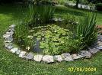 in the garden.
⃞ sea
⃞ pond
⃞ river
⃞ fish bowl
⃞ cave

