NAME: CLASS:
GWINETH AND THE WIZARD (FINAL TEST)
A) FILL IN THE BLANKS WITH THE CORRECT FORM OF THE VERBS IN BRACKETS. (22 points)

- If you want to say that you are twelve, everybody _______________________ (believe) you, girl.
- When you _____________________(finish) you'll do something better.
- Nobody would know if she ___________________ (open) the door.
- If you get near the tower, you ____________________ (lose) your job.
- If Gwineth ________________(work) fast, she will finish before sunset.
- If you do all your exercises, you __________________ (learn) a lot of English.
- What would happen if the wizard _______________ (come)?
- If I were you, I ____________________(not run) away.
- Gwineth _______________ (not work) in the castle, if she had money.
- She would find her mother if she ______________ (can)
- If the weather _______________(be) fine we would go out for a walk.
B) REWRITE THE FOLLOWING SENTENCES USING UNLESS. (10 points)
- If you are not rich and powerful, you will never have a castle.

2. Aunt Rose won't get well if Gwineth doesn't get money for medicines.

3.If Gwineth doesn't work in the castle, nobody will pay her.

4.If the steward doesn't like her job, she will leave the castle.

5.She will never grow up if she doesn't eat more.
C) VOCABULARY.COMPLETE: (24 points)

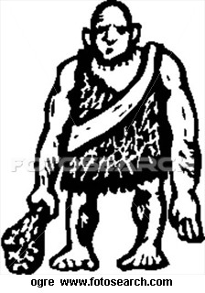 |  | 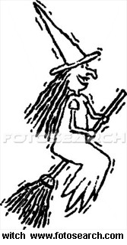 | 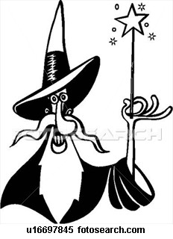 | 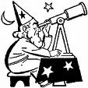 | 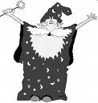
O___________ | M__________ | W________ | He is holding a  m________ w________ | A_________ | W_______

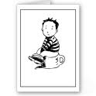 |  |  |  |  | 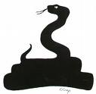
The boy is sitting on a c________ p________ | S_________ | D___________ | This means the product is p___________ | B___________ | S___________
D) COMPREHENSION: COMPLETE THE FOLLOWING SENTENCES: (12 points)

1. Gwineth lived with her aunt because......
2. Gwineth went o to the castle to...........
3. As a servant in the castle she had to........
4. One day she saw a ............. coming from behind the door of the tower and she heard a
strange...........
5. The tower was a large room. There were ........ ...........................................................
.............................................................................................................................................................................................................................. ...........in the tower.(give as many details as possible).
6. There were an old ...................... with incantations.
7. The door said to the Wizard: "You need an ......................... If I were you I would take her"
8. The wizard explained that it was........................... to be involved in magic those days.
9. Gwineth's best friend was a dragophant which is a ............................................
10. The wizard said: "If you work hard you may became the most powerful ............................... in England".
11. Gwineth wanted to become powerful enough to find her ................
12. When they said the spell again, back to front the dragophant reappeared on .................... ................ foot.
E) PRONUNCIATION: PUT THE FOLLOWING WORDS IN THE RIGHT PLACE. (TWO OF THEM ARE DISTRACTORS): (8 points)
one, here, quiet, jam, music, beautiful, use, yam, choir, why.
/j/:
/w/:
F) YOUR PRODUCTION: IF YOU WERE A WIZARD OR A WITCH, WHAT WOLD YOU DO? (24 points)

ISABEL GIL ALMANSA I.E.S. SALDUBA SAN PEDRO ALCÁNTARA

