NAME: CLASS:

BERTIE (FINAL TEST)

A) As you know, Bertie's house was built a long time ago. Since then, Many changes have been made.
Compare the two pictures and COMPLETE THE SENTENCES. (10 points)
eg. The walls have been painted.
Use these verbs
plant put up do repair place
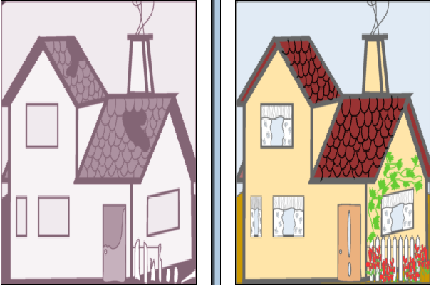
1. The roof ....................
2. Flowers ..................
3. The curtains ........................
4. The door ......................
5. The fence .....................
B) CHANGE INTO THE PASSIVE VOICE: (10 points)
1. Shakespeare wrote Hamlet.
2. Bertie's grandfather built this house.
3. They removed the clock from the front of the Town Hall.
4. They haven't demolished the school yet.
5. They have turned the park into a car park.
C) CHANGE INTO THE ACTIVE VOICE: (10 points)
1. The telephone was invented by Bell.
2. The water is heated by the sun.
3. My application was accepted by the manager.
4. They had built a new theatre.
5. English is spoken in this shop.
D) VOCABULARY: (20 points)
Write the correct words for the following definitions:
1. a long-handled pan used for frying food: .........................
2. To make a typical Spanish ............................ you'll need some potatoes and eggs.
3. A body of water smaller than a lake: ..........................
4. The head of government of a cityor town: ................................
5. An area or building reserved for parking cars: ...................................
6. In Cervantes' most famous novel, Don Quixote fights ...........................that appear as giants to him.
7. A ............................................. is a panel exposed to radiation from the sun, used to heat water or, to produce electricity.
8. To fry potatoes, you have to ........................ the oil.
9. A building that houses the Town Council:...............................
10. You should put up a wooden .................................. to separate your house from the swimming-pool.
E) PRONUNCIATION. (20 points)
Put the following past participles in the rignt place:
planted repaired worked watched needed liked opened injured visited
ending in /t/
ending in /d/
ending in /id/
F) IMAGINE you met an English boy of your age in a chat room. This morning you recieve an e-mail asking you to tell him about yourself, your family, the place where you live, etc. He also asks you a favour: he would like to know how to make a real Spanish omelette, which he loves.. WRITE YOUR REPLY. (Use at least two passive sentences). (30 points)

Isabel Gil Almansa. I.E.S. Salduba San Pedro Alcántara

