Follow these instructions to work on your computer
The Treasure Hunt

1 | Insert the DVD in the DVD reader and ...the autorun will start automatically.
2 | If the autorun doesn’t work... open the file “malted” , look for the icon and double click on it.
3 | If the window displayed looks like this,  ...go to “Inglés Secundaria”  “Unidades Didácticas” |  | 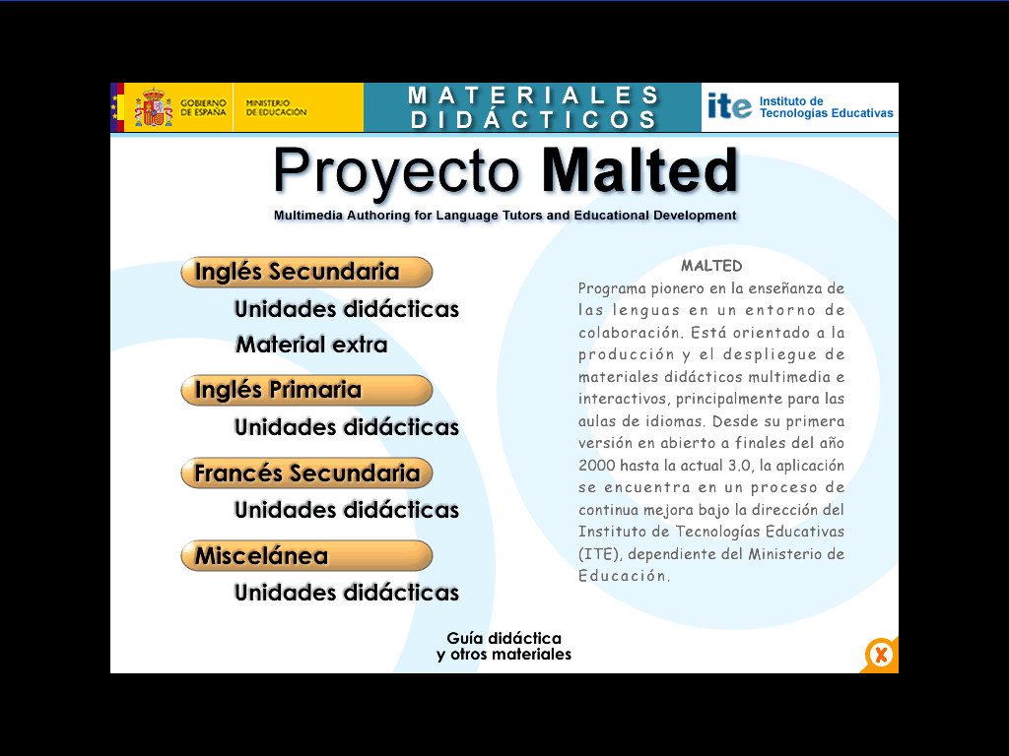
4 | If you see this screen on display  You’ll have to double click “4º ESO” |  | 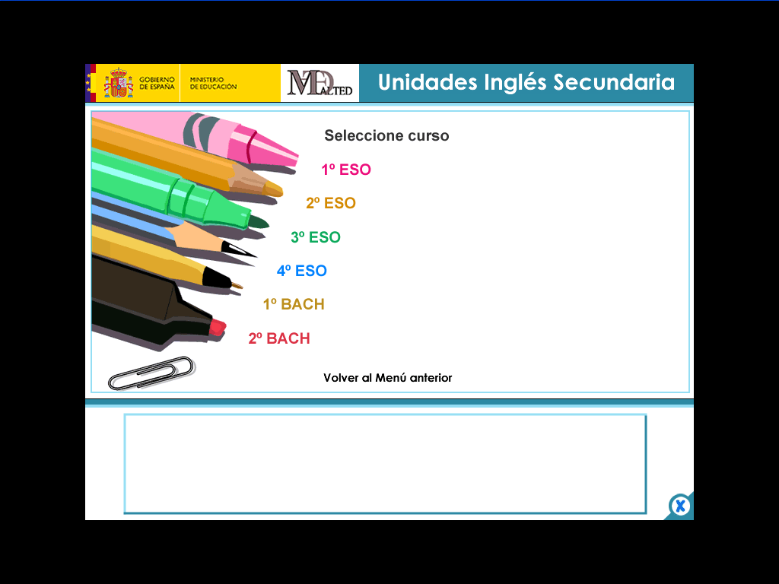
5 | 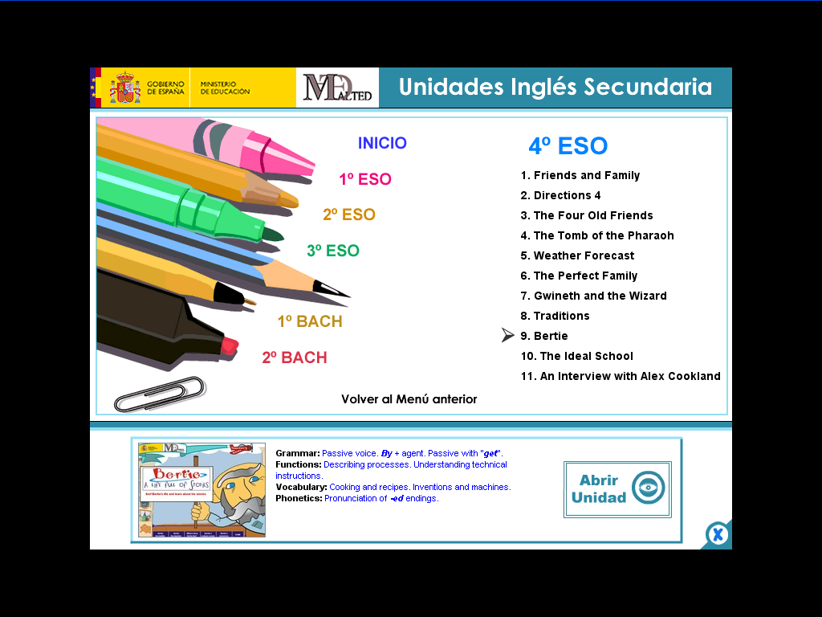 |  If this is your next screen, look for “Bertie” on display and double click on “Abrir unidad”.
6 | If this is it what you see, now you are ready to set off!   Good Luck and enjoy yourself! |  | 