“MY NEIGHBOURS” TEST
NAME:
DATE:

1. Have a look at this picture and answer the following questions:(10)

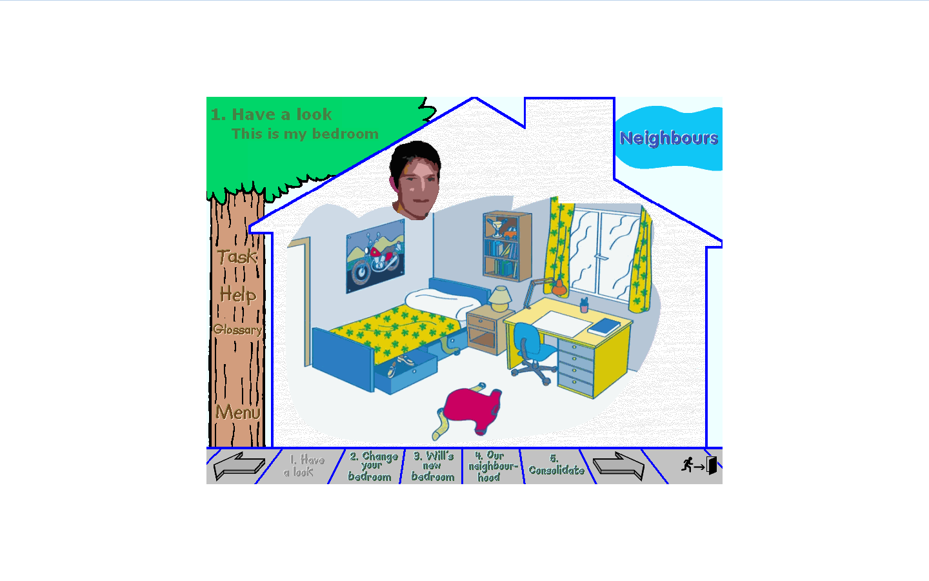
- What is “Task”?
- What is “Help”?
- What is “Glossary”?
- Where is the bedside table?
- Are there any shelves?
- Where is the window?
- Where is the desk?
- What is on the walls?
- Is there a wardrobe?
- Is Will’s bed under the window?

2.- Draw a house and write the names of the rooms in it: (6)

3.- Read the conversation between Will and Andrew and answer the questions: (10)

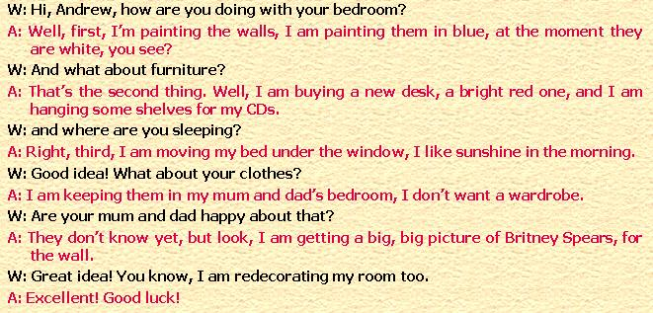

- Who is Andrew?

- What colour are the walls in Andrew’s bedroom at the moment?

- What colour is Andrew painting the walls?

- What is he buying?

- What is he hanging?

- Where is he moving his bed? Why?

- Where is he keeping his clothes? Why?

- Whose picture is he getting for the walls?

- What is Will doing?

- What does “Good luck” mean in Spanish?

4.- Write sentences in the present continuous: affirmative, negative or interrogative: (5)

- Lucy (study) today.
- Mr. Lloyds (not play) the violin.
- Ben and Pat (change) their room?
- Will (not paint) the walls now.
- You (put) a poster in your room?

5.- Complete the text with one of the words from the box: (9)

Giving, putting, redecorating, moving, doing, painting, getting, helping, buying

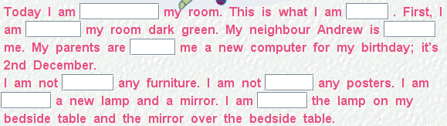

6.- Write these dates: (4)

- 2/01/2009
- 23/08/2009
- 31/04/2009
- 12/02/2009

7.- Listen to the teacher and write the words you hear: (6)

TOTAL 50 A:43-50 B:34-42 C:25-33 D:12-24 E:0-11

