JUAN RUBIO LOZANO
CEIP EUROPA (LINARES)
6º DE PRIMARIA
PUPIL'S NAME: _________________________________________________________________

POST-TEST: THE TOWN (1º ESO)

- LISTENING
  - Listen. Tick (True), cross (False) or ? TRUE FALSE ?
    - Mike is twenty years old. _____ ______ ______
    - The town is noisy. _____ ______ ______
    - It is next to the sea. _____ ______ ______
    - Many people live in the town. _____ ______ ______
    - There are banks and cinemas. _____ ______ ______
    - There is a shopping mall. _____ ______ ______

____/6 points
  - Listen looking at the map, follow the way with the pencil and tick the correct house.
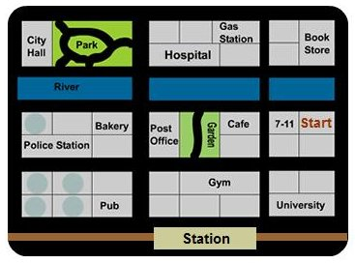
____/6 points
  - Listen and write the names of the places
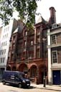  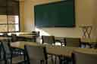 |  |  |  | 
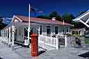 | 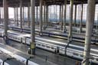 |  | 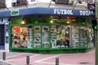 |   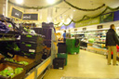
____/10 points
- READING AND WRITING
  - Look at the map and answer the questions below

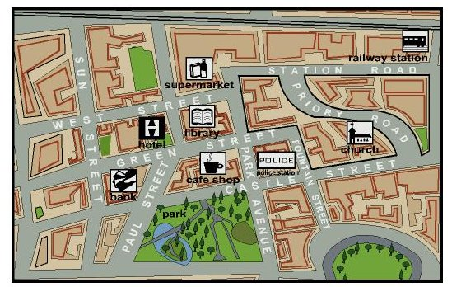
1. Can you tell me the way from the railway station to the café shop?
_______________________________________________________
_______________________________________________________
_______________________________________________________

2. Can you tell me the way from the supermarket to the church?
_______________________________________________________
_______________________________________________________
_______________________________________________________
____/6 points

  - Describe the places there are in your town. You must use there is, there are and prepositions of place.
_______________________________________________________
_______________________________________________________
_______________________________________________________
_______________________________________________________
_______________________________________________________
_______________________________________________________
_______________________________________________________
____/7 points
  - Read and answer the questions
    - In her way to school everyday she goes out of her house and turn right. At the end of a small block she goes pass a pub and then turn right. After that she walks along a wide street and goes pass two blocks with a lot of shops. At the intersection there are three banks an one chemist's and then she turns right again and goes straight on the new long street. At that street there is a museum, a church and a department store between them. At the end of the street there's a clothes shop and a café.
      - When she goes out of her house, what does she do: _______________________
      - What does she pass at the end of a small block? __________________________
      - What is there in the intersection? ______________________________________
      - Is there a hospital in her way to school? ________________________________
      - Are there five banks in her way? ______________________________________
      - Where is the department store? _______________________________________
____/6 points

- GRAMMAR
  - Complete sentences with There is or There are.
    - ________ ____ two libraries in my block
    - ________ ____ a garden near near the police station
    - ________ ____ many people in the sports centre
    - ________ ____ one cinema in my street
    - ________ ____ seven persons in the post offcie
    - ________ ____ fourteen shops in shopping mall
    - ________ ____ an art museum near the department store
    - ________ ____ three flags in the window of the town hall
____/4 points
  - Write these sentences in order.
    - There / lots / baker's / village / are / in / of / the
______________________________________________________
    - a / in / is / block / my / There / cinema
______________________________________________________
    - five / in / There / street / are / banks / our
______________________________________________________
    - supermarket / post office / is / between / There / a / the / the /hospital
______________________________________________________
    - Spain / are / museums / in / There / many
______________________________________________________
    - opposite / square / is / There / a / town hall / the
______________________________________________________
____/6 points
  - Complete sentences with prepositions of place and time
    - We've got P. E. _____ Fridays
    - I always have lunch _____ half past two
    - The milk is _____ the glass
    - The cat is _______ the chair
    - We go on holidays _____ July
    - There is a butcher's __________ the toy shop and the chemist's.
    - The shopping mall is _____ to the park
    - The otter is sitting ______ a tree
    - The bank is in ________ of the supermarket
    - ____ Sundays we visit our family
____/5 points

  - Draw and write 3 road signs with must and 3 with mustn't

OBLIGATIONS (must) | INTERDICTIONS (mustn't)
____/6 points
- SPEAKING
  - Talk to the teacher describing this city using: places, there is / are and prepositions of place. You must say at least 10 sentences.

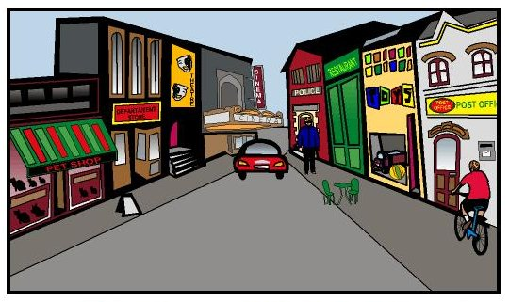
____/10 points

  - Can you tell me the way …

    - … from the bank to the supermarket?
    - … from the church to the hotel?
    - … from the library to the railway station?
    - … from the park to the railway station?

____/8 points

TOTAL …...... _____ / 80 POINTS

