JUAN RUBIO LOZANO
CEIP EUROPA (LINARES)
6º DE PRIMARIA
PUPIL'S NAME: _________________________________________________________________

POST-TEST: FAR WEST (1º ESO)

- LISTENING

  - Listen and complete the text.

It ____ a hot morning in June. The town of Gunhill ____ quiet and peaceful. A man ________ on his horse. He ______ black clothes, a black cowboy hat and a _______ with two ______. He _____ Pat Carson, the _______ gunman. Everybody ________ him. He _________ in front of a boy and ______ to him.
- Hey boy, ______ is your name?
- _____ Ted MacNally
- Listen Ted. I'm ________ for Sam Smith. Where can I find him?
- I ______ know, sir. Sorry. I ______ go now
Ted ______ that Sam _____ at the saloon, but he ___________ the gunman. He ____ afraid. Sam was his friend.

____/10 points

  - Listen and answer the questions.

    - Where did Ted run to? _____________________________________________
    - Was the sheriff at his office? ________________________________________
    - Where did the old man live? ________________________________________
    - Where was he? __________________________________________________
    - Where was the sheriff? ____________________________________________
    - What did Ted say to the old man? ____________________________________
____________________________________.

____/6 points

  - Listen and complete the dialogue. You are Ted MacNally.

    - Are you Sam Smith?
    - __________________________
    - My name is Carson, Pat Carson!
    - __________________________
    - I have something for you!
    - __________________________
    - Here you are. Your uncle Billy in my friend. He gave me this gun for you.
    - __________________________

____/4 points

- READING AND WRITING

  - Complete the sentences with the Past Simple of these verbs.

be, come fear, know, live stop, talk, wear

    - Pat Carson __________ to Gunhill in June.
    - That morning it ________ very hot.
    - The gunman was dangerous and everybody ______ him
    - He __________ in front of Ted MacNally.
    - The boy ___________ brown trousers and a check shirt.
    - Ted MacNally ________ Sam Smith. They were friends.
    - The sheriff was not in the office and Ted _______ to an old man.
    - The old man _______ next to the sheriff's office.
____/8 points

  - Read the text from the Listening 1 and answer the questions

      - It was winter or summer? ___________________________________________
      - How was the town of Gunhill?_______________________________________
      - Did the gunman come by car? _______________________________________
      - Did the gunman wear a white hat? ____________________________________
      - Where did the man stop? ___________________________________________
      - Who was Sam? ___________________________________________________

____/6 points

  - Write the Far West story with about 8 sentences. Two sentences for each par of the story: Gunhill, Sheriff's office, Barber's shop and Saloon.

    - __________________________________________________
    - __________________________________________________
    - __________________________________________________
    - __________________________________________________
    - __________________________________________________
    - __________________________________________________
    - __________________________________________________
    - __________________________________________________
____/8 points

4. Complete Sam's letter.

_____ uncle Billy,

Thank you for your present. It is a fantastic ______. Pat Carson gave it to me. I was afraid because he is a gunman. I ______ know that he is your ______.He came to town ____________ morning and asked Ted MacNally about me. Do you remember little Teddy?. He is now eleven ______ old. After that, Carson _____ to the barber's shop. The __________ told him that I was in the _______ and he found me there. Then _____ went home for lunch. He is very nice.
____/10 points
- GRAMMAR

  - Write the Past simple and the meaning of these verbs
Past simple Meaning
talk __________ __________
paint __________ __________
play __________ __________
visit __________ __________
wash __________ __________
study __________ __________
watch __________ __________
listen __________ __________
____/8 points

  - Sort these verbs in regular and irregular according with their past forms. Write the verbs in past form.
live, start, run, go, wait, know, ask, stop, be, come, paint, wear

Regular Irregular
______lived_______ _________ran_______
_________________ ___________________
_________________ ___________________
_________________ ___________________
_________________ ___________________
_________________ ___________________
____/5 points

3. What do these rules mean?:
Rules / Reglas | Meaning / Significado
General rule
Verbs ending in -e
Verbs ending in consonant + y
Verbs ending in 1 vow. + 1 cons

____/8 points
3. Write the sentences in order

1. did / Carson / do / What / Pat / ?
_______________________________________________
2. recognized / The / Carson / didn't / Pat / barber
_______________________________________________
3. is / time / usually / He / this / at / there
_______________________________________________
4. Did / ? / saloon / the / he / to / go
_______________________________________________
5. horse / and / He / his / went / in / tied
_______________________________________________
6. he / saloon / didn't / go / to / the / No,
____/6 points

- SPEAKING

  - Looking at the picture tell me what did you do last weekend.

Last weekend I ….
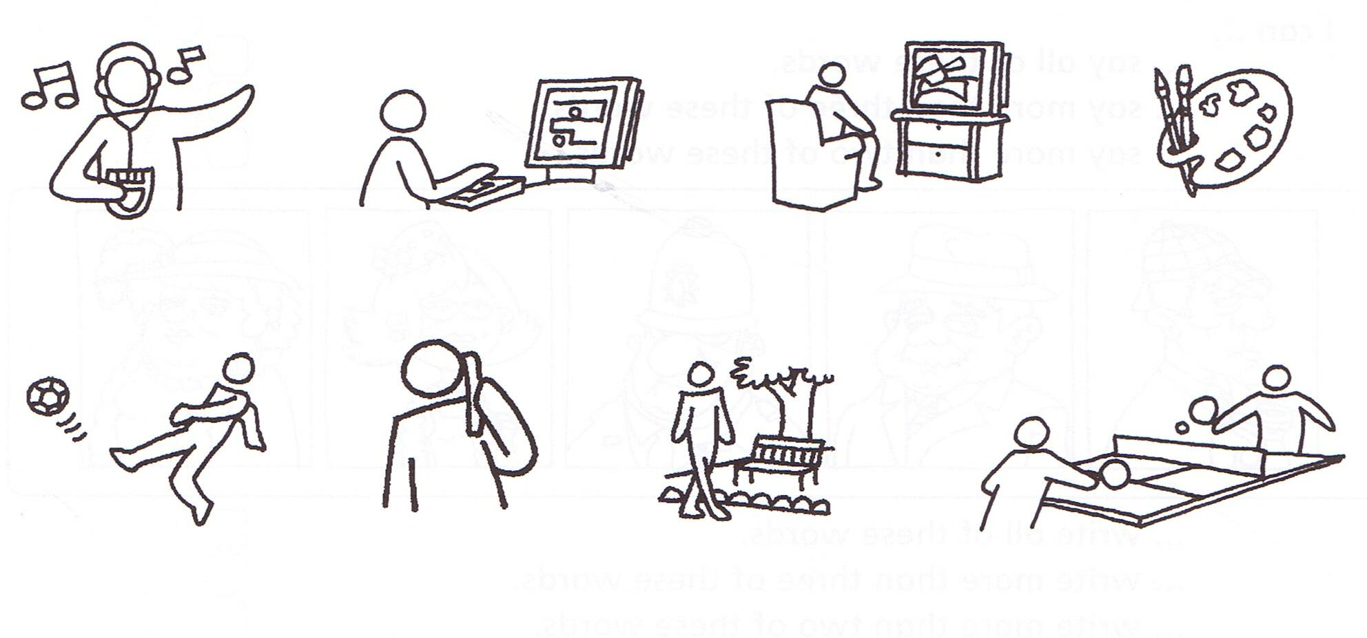
____/8 points

  - You must choose one of these characters: Narrator, Pat Carson or Sam Smith. With the help of other classmate (barman) you must act out the dialogue in the saloon, part. 4.

____/10 points

- TOTAL …...... _____ / 97 POINTS

