MALTED EN EL AULA -VIRGINIA GARCÍA ROMERO-

STUDENT´S NAME:…………………………………………………….

UNIT: THE TOWN PART 4: IN THE STREETS

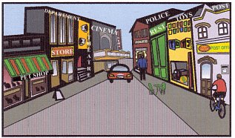

1. Where is the restaurant?

…………………………………………………………………………..

2. What is opposite the post office?

…………………………………………………………………………...

3. Where is the toy shop?

…………………………………………………………………………..

4. Where is the department store?

………………………………………………………………………….

5. Is it the theatre opposite the restaurant?

………………………………………………………………………….

