MALTED EN EL AULA -VIRGINIA GARCÍA ROMERO-

FINAL TEST UNIT: MY SCHOOL
STUDENT´S NAME: ___________________________________________________

1. Circle the right answer.

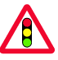
You must stop when the light is red.

You must stop when the light is green.


You must go back.

You mustn´t go back.


You must be careful.

You mustn´t be careful.

2. Complete with the prepositions of time: at, on, in

The programme starts ………………7 o´clock
.
We usually go to my grandmother´s house ………….. Sunday.

It sometimes rains ………….. June.

My sister was born …………. 1995.

3. Complete with: next to, between, in, near, in front of, opposite.

Who is sitting ……………………Bill?

There are no secrets ……………….them.

There is a bus stop ……………… my house.

There were two girls swimming …………..the river.

There is a pay phone ………….. that monument.

The view …………………. our hotel was fantastic.

4. Describe your city. Write about its places.

----------------------------------------------------------------------------------------------

----------------------------------------------------------------------------------------------

----------------------------------------------------------------------------------------------

----------------------------------------------------------------------------------------------

5. Write the orders

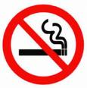 | 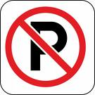
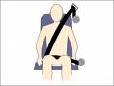 | 

6. Translate into Spanish

Don´t be late
Tidy the classroom
Clean the board
Talk to your partner
Be quite

7. Write in English.

Siéntate
Haz los deberes
Escucha el cassette
Abre el libro
No abra la ventana

8. Read carefully and draw.
Greenland is a small mountain village. The principal street is called "The High Street".
There is a post office opposite the supermarket. There are many trees and there is only one school next to the post office. There is one hotel between the supermarket and the church.

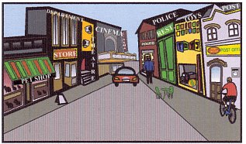
9. Write True (T) or False (F)

- There is a cinema on the corner of the street.

- There is a post office between the pet shop and the theatre.

- There is a department store opposite the pet shop.

- There is a car in front of the theatre.

- There is a restaurant next to the police.

