WORKSHEET: COMPARISON

NAME ……………………………………………………………………………………

1- REWRITE THESE SENTENCES SO THAT THEY MEAN THE SAME AS THE ORIGINAL ONES:

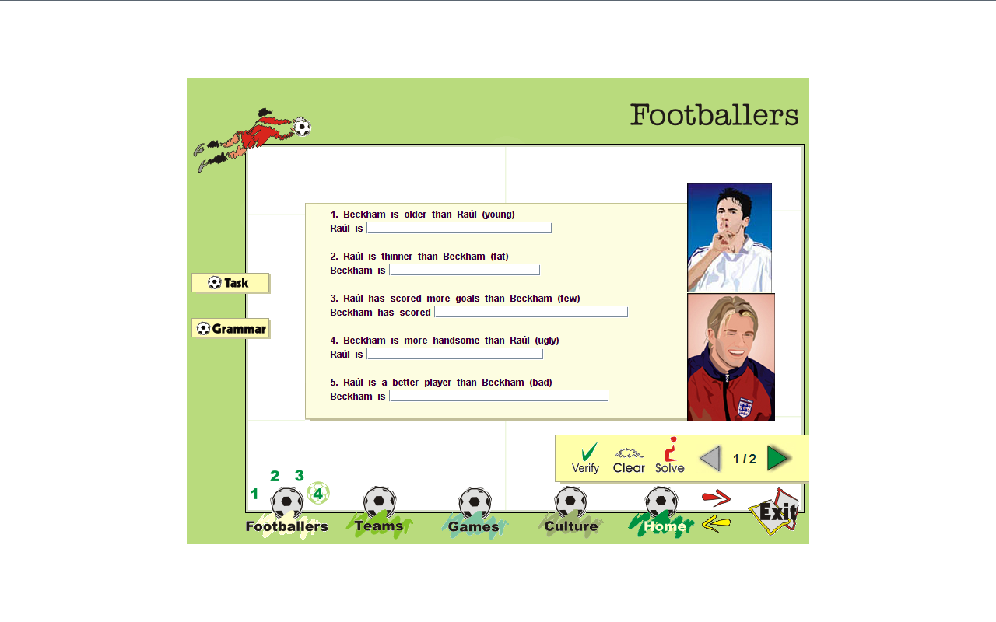
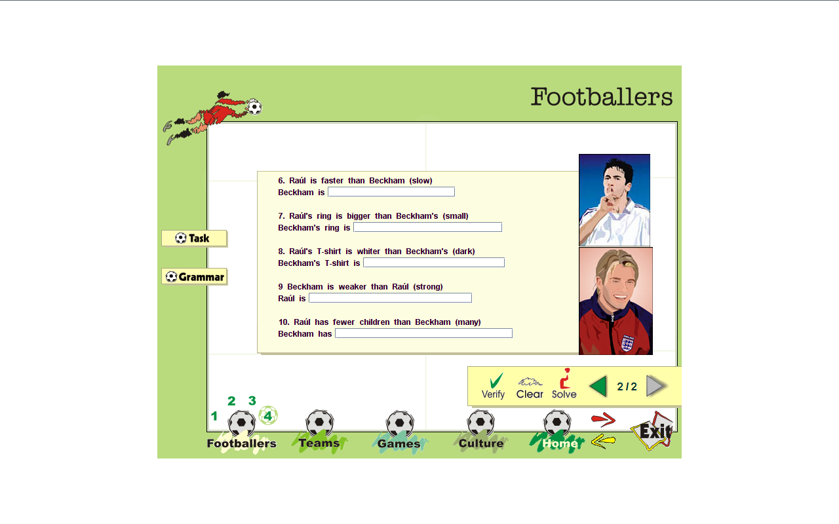

2-HAVE YOU HEARD OF THE CHEETAH GIRLS ? WRITE 5 SENTENCES USING THE INFORMATION PROVIDED.USE COMPARATIVES.





Adrien Bailon Sabrine Bryan Kiley Williams
Born: 1983 born: 1984 born: 1986
Height: 152 cm. height: 163 cm. height: 172 cm
Hair: brown hair: fair hair: black

- …………………………………………………………………………………………
- …………………………………………………………………………………………
- …………………………………………………………………………………………
- …………………………………………………………………………………………
- …………………………………………………………………………………………

3- HERE ARE SOME WORDS YOU HAVE ALREADY STUDIED.CLASIFY THEM.THEN WRITE REALLY INTERESTING AND DESCRIPTIVE SENTENCES.DON´T USE THEM MORE THAN ONCE:
STRIPED BOOTS FLOWERY PLAIN JACKET TROUSERS

BELT CAP CHECKED SPOTTED SCARF PATTERNED

- …………………………………………………………………………………………
ADJECTIVES
NOUNS
- …………………………………………………………………………………………
- …………………………………………………………………………………………
- …………………………………………………………………………………………
- …………………………………………………………………………………………
- …………………………………………………………………………………………

4- READ THE TEXT CAREFULLY:
THE GAME

Football began in England. It’s a very old game, older than basketball or tennis. It’s more than a hundred years old
and it’s the sport with the largest number of supporters in the world.
In the past, football was a game for fun, but nowadays it is the richest sport all over the planet and football players
are the best-paid sportsmen of all times.
Football supporters are the most faithful and enthusiastic fans in the world, but there are some violent supporters in
every team. They are called hooligans and they are the most dangerous football fans. They do not enjoy the game,
they only spoil it.
- Ask questions for the underlined:
  - …………………………………………………………………………………………
  - …………………………………………………………………………………………
  - …………………………………………………………………………………………
  - ………………………………………………………………………………………….
  - …………………………………………………………………………………………
- What do these pronouns refer to?
  - line 1: it………………………………………….
  - Line 7: they……………………………………..
  - Line 7: it…………………………………………
- According to the text, answer these questions ( long answer ):
  - What was football in the past a game for?
…………………………………………………………………………………………
  - Which sport is older, basketball or tennis?
…………………………………………………………………………………………
  - How does the text say football supporters are?
…………………………………………………………………………………………
- Define ‘hooligan’: …………………………………………………………………………

