Where to buy what
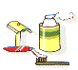 | Chemist's
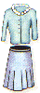 | Ladies Clothing Shop or Boutique
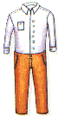 | Mens Clothing Shop or Tailor's
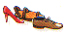 | Shoe Shop or Cobbler's
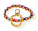 | Jeweller's
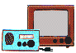 | Electrical Store
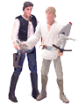 | Toy Store
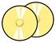 | Record Shop
 | Book Shop
 | Newsagent's
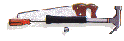 | Ironmonger's
 | Optician's
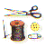 | Haberdasher's
All or most of the above | Department Store
 | Butcher's
 | Fishmonger's
 | Greengrocer's
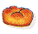 | Baker's
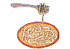 | Delicatessen
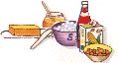 | Grocer's
 | Off Licence
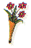 | Florist's
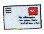 | Post Office
All or most of the above | Supermarket

