- FICHA DE TRABAJO “ EARTH MISSION”

QUICK QUIZZ

I-Match buttons function
- Task | - Ver nuevas palabras
- Help | - Comprobar respuestas
- Verify | - Adelante
- Clear | - Explicación gramatical
- Dictionary | - Tarea
- Exit | - Atrás
-  | - Ayuda
- Learn more | - Adelante
9.          | - borrar

II- WHO IS ZZP ?
Give information to your teacher

III- Complete the letter from ZZP
Hello,I´m PP1. I am from Mars.
I have got a letter from my brother ZZP :

“ Dear PP1.Hello, I am on the Earth now.It is a strange
planet. There is a family here, The Smiths.
………..… is the father and ……..…… is the mother.Their ……..…. is
is Andrew and their …………………..… is Sue.They have got a pet.,
……………. name is Mozart and it likes …..…………… and ……………….. .
There are cities and streets and houses , families live there.
It´s great fun and I like going to restaurants and shopping.
Come to visit this planet. Kisses ,
ZZP

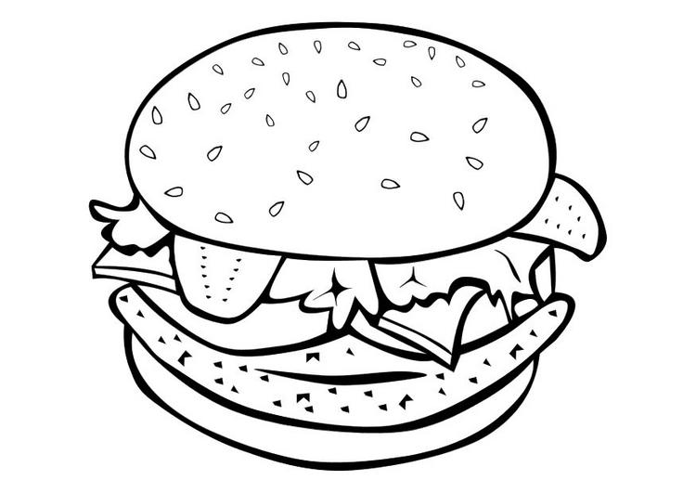
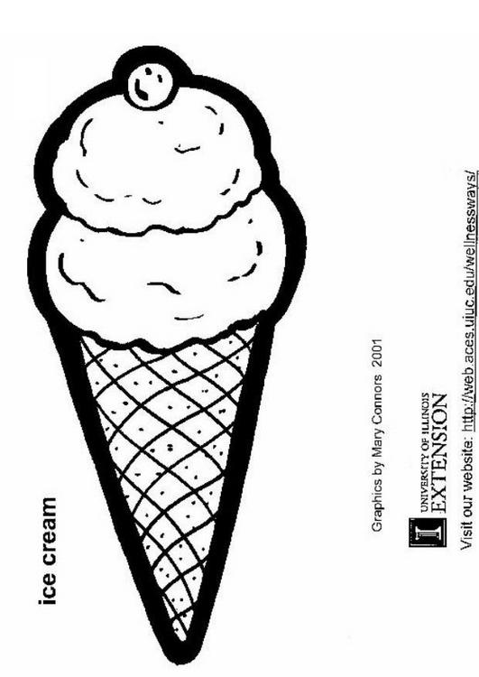
IV- YES / NO
ZZP hates chicken. ………
Andrew loves ice cream. ………
Peter doesn’t like salad. ……….
ZZP loves hamburgers ………

V-Where can ZZP get….?
aspirines ___________ bread ___________ sweets___________
a bird ___________ money ___________ sugar ___________

VI- ZZP ’S HOUSE.
    - Name the rooms from left to right.
    - Name some examples of furniture.
    - Colour the walls of the house:

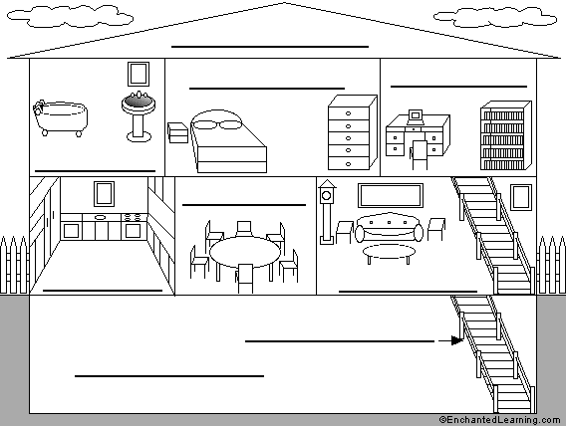

VII- DRAW ZZP ’S FAMILY TREE:
GUBI is ZZP’s father
LOL is ZZP’s mother
PP1 is ZZP’s sister
MEM is ZZP’s grandmother and HIO is ZZP’s grandfather.
POP is ZZP’s uncle and SAX is ZZP’s aunt.
BIBO is ZZP’s cousin.

Finally answer these questions:
Who is GUBI’s wife?
Who is BIBO’s father?
Who is SAX’s daughter?
Who is PP1 ‘s brother?

